Multimedia Presentation Documentation

Andrew Wong &  
Shaurya Thiharie

10IPT1

Multimedia Presentation Documentation

**Table of Contents**

Design Features 2

Project Development Plan / Timeline 5

Roles/Task Allocation 5

Sub–Projects 5

Planning 5

Design Webpage 5

Technology Information 5

Design Tools 6

Storyboard 6

Gantt Chart 7

Diary/Log 9

Assessment Questions 10

Describe the process of including a video clip into the presentation 10

Describe the process of making your presentation available for viewing on the WWW 10

Power House Museum Rework – Info Kiosk 11

# **Design Features**

* Right–click Navigation Context Menu – Allows the user to jump to different pages in the presentation with a custom content menu.  
  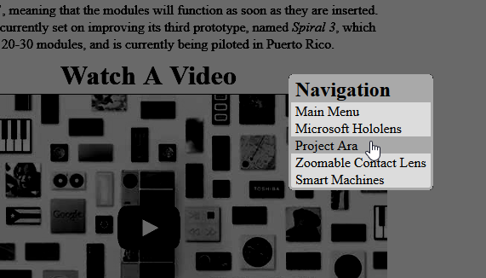
* Fade Effects – Provides transitioning between pages and also emphasises a selected option.  
  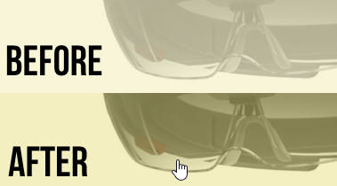
* Header & Footer Dynamic Colour Scheme – Instils uniqueness from each category. When a category is selected, the header’s and footer’s colour change to the same colour scheme as the category.  
  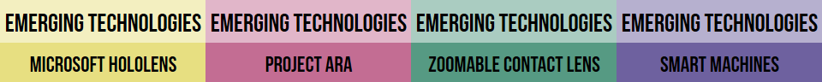
* Home Button – Allows the user to return to the start of the presentation by clicking on the Home button, located top left of the page. It will be seen in full opacity when functional.  
  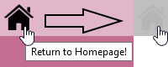
* Fullscreen Prompt – A fullscreen prompt will appear on the first visit of the presentation of a browser session. Fullscreen mode is felt to be more immersive.  
  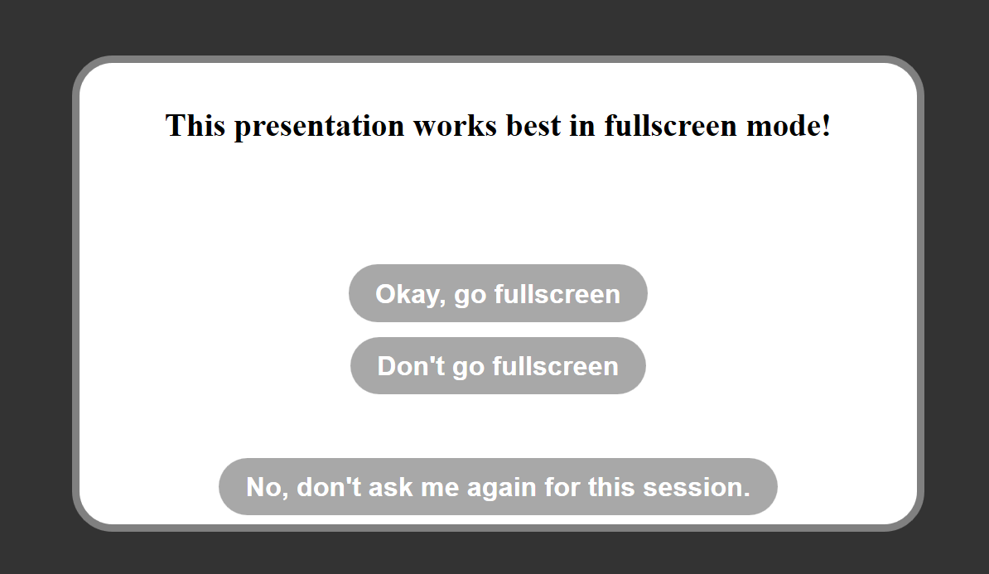
* Videos – Provides an audible and visual learning experience.  
  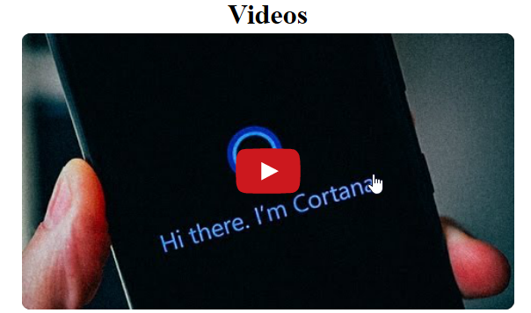
* Text Zoom – Emphasises selected option  
  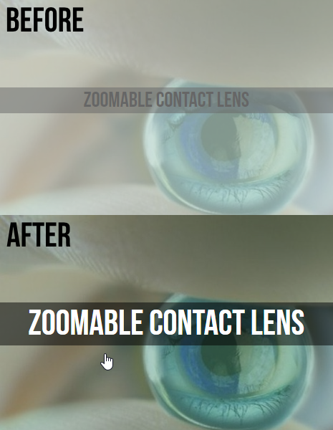
* White Background – Increases text contrast

# **Project Development Plan / Timeline**

## Roles/Task Allocation

|  |  |  |  |
| --- | --- | --- | --- |
| Category | Task / sub–project | Andrew | Shaurya |
| Design | Mock–ups |  |  |
| Design | Presentation (HTML) |  |  |
| Design | Merge Information |  |  |
| Planning | Research Technologies |  |  |
| Planning | Feature List |  |  |
| Planning | Storyboard |  |  |
| Planning | Gantt Chart |  |  |
| Planning | Documentation |  |  |
| Question | Video Clip Inclusion Question |  |  |
| Question | WWW Question |  |  |
| Question | Kiosk Usage Question |  |  |

## Sub–Projects

### Planning

* Decide upon presenting with PowerPoint or HTML
* Create mockups
* Transcribe mockups into a storyboard form
* Update progress log (The third design tool)

### Design Webpage

* Find website icon resources – Home icon
* Decide on website colour themes – Category colours
* Create JavaScript functions
  + Full screen prompt – Asks and attempts to make the web browser enter fullscreen mode
  + Right–click navigation context menu – Custom right click menu to navigate the presentation
  + Header and footer colour transition with selected category
  + Create and re–use existing utility snippets

### Technology Information

* Research four different technologies
* Find relevant and suitable images and videos

## Design Tools

### Storyboard

Refer to A3 sketch. Below copy is a scan

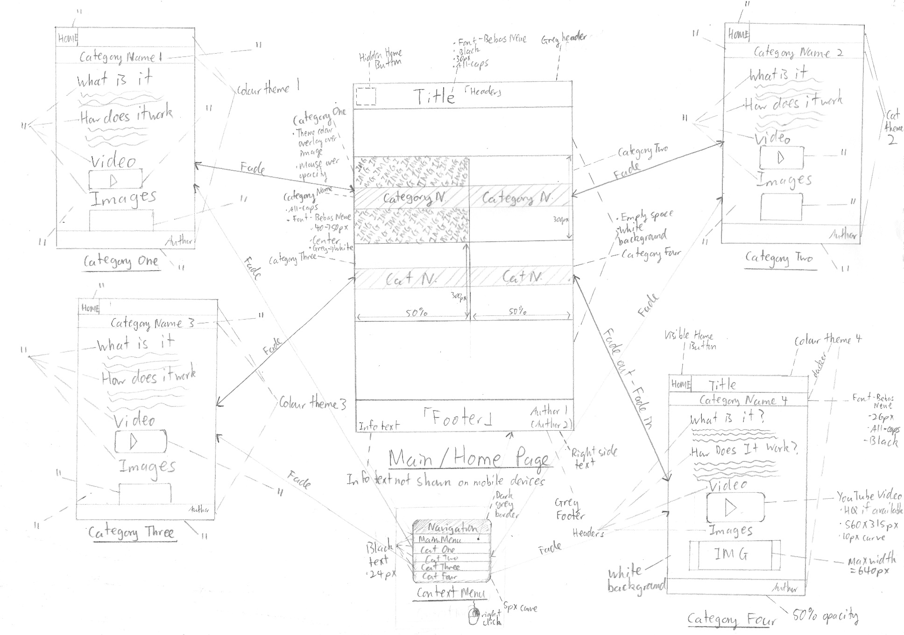

(Main/Index Page)

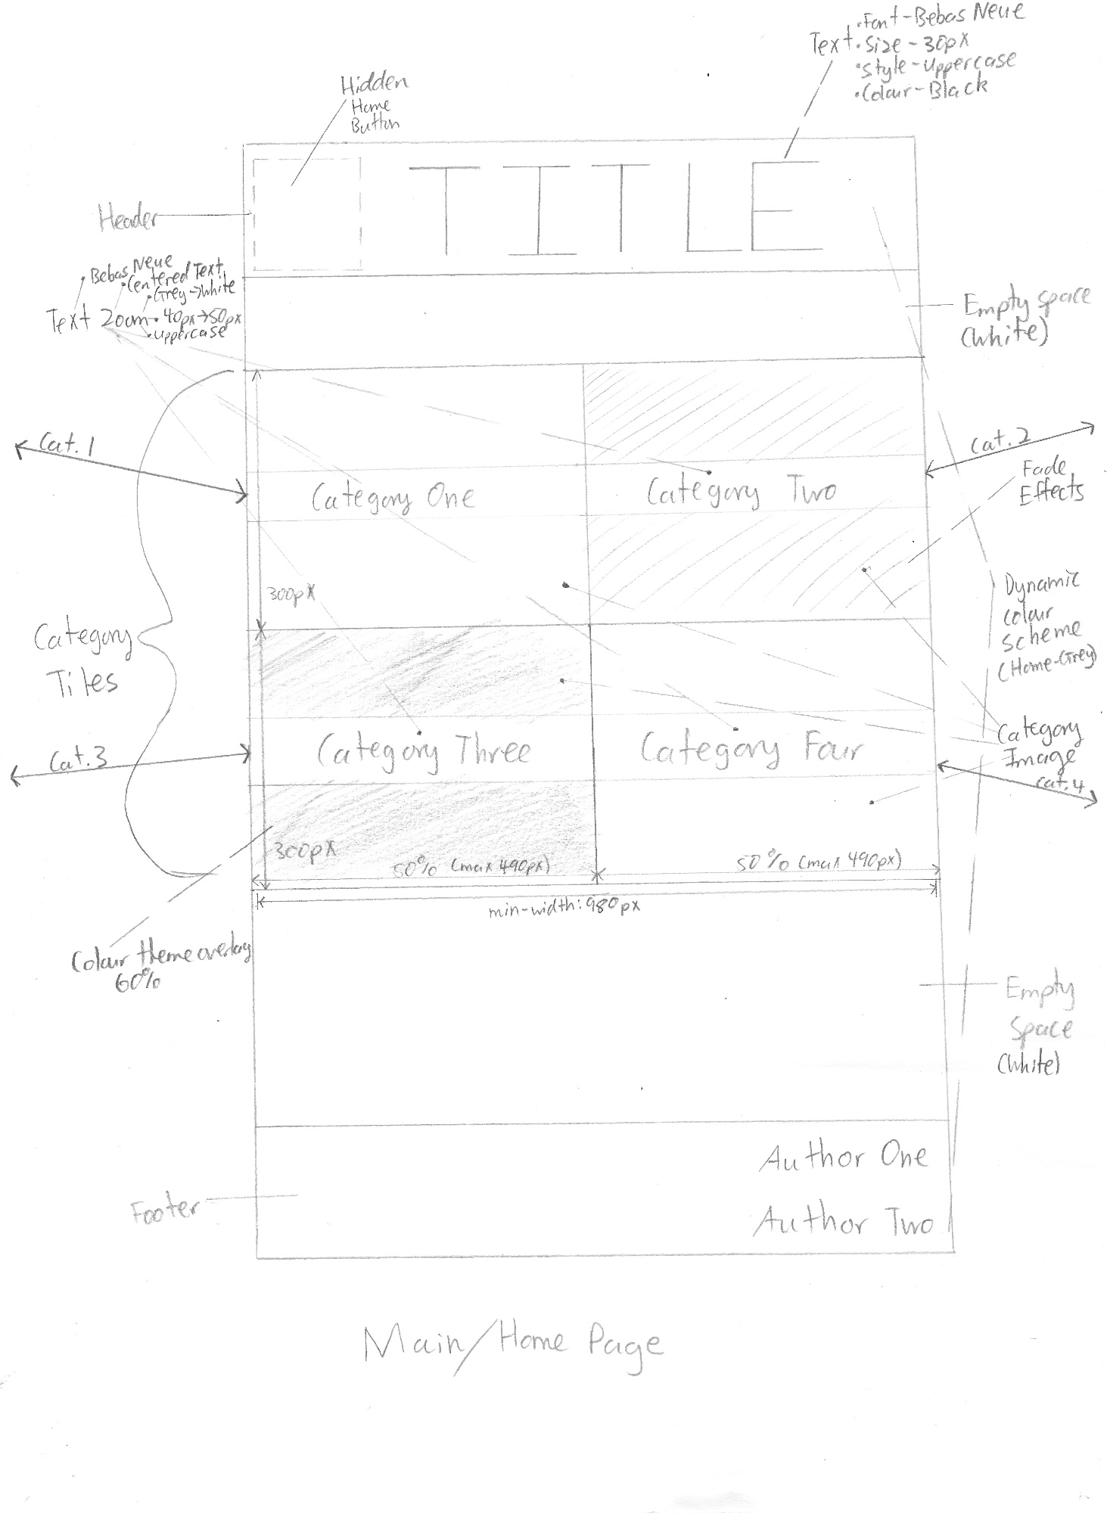

Refer to A3 sketch. Below copy is a scan

### Gantt Chart

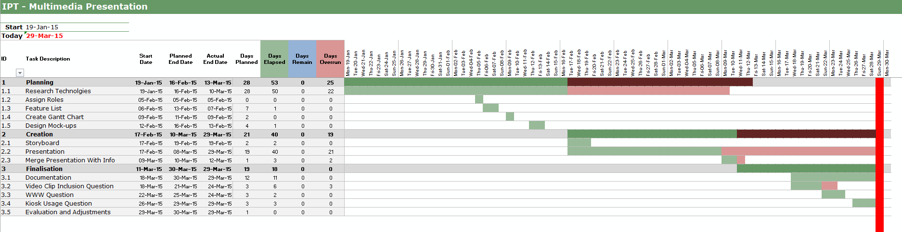Overall Gantt Chart

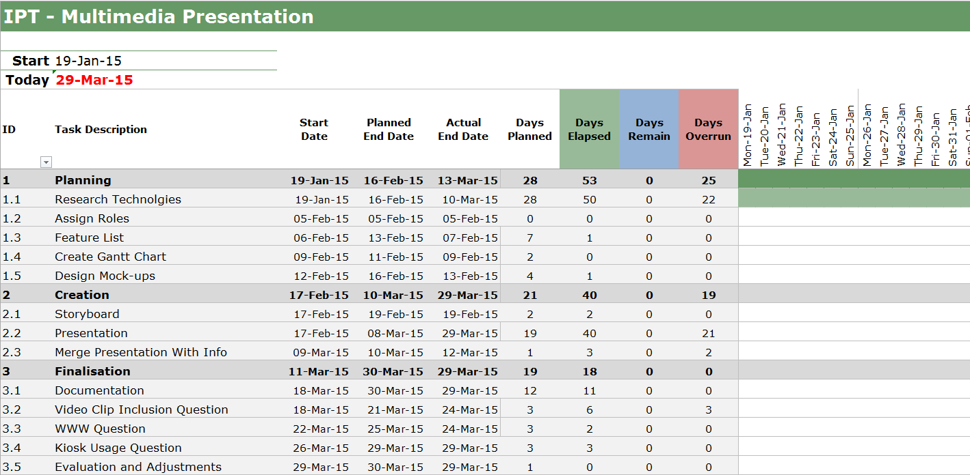

Zoom of Gantt Chart

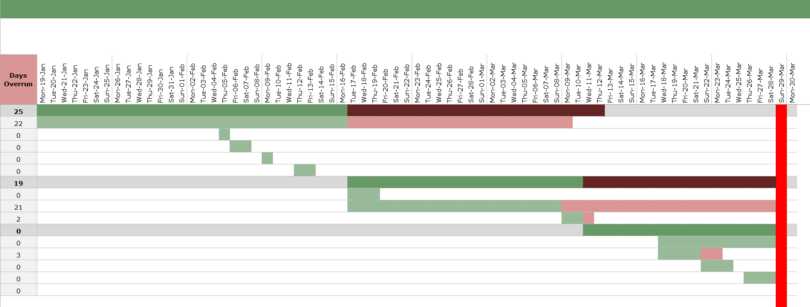

Zoom of Gantt Chart (Red represents days overrun)

### Diary/Log

|  |  |  |
| --- | --- | --- |
| Date | Person | Notes |
| *19/01/2015* | BOTH | Receive assignments |
| *19/01/2015* | BOTH | Research emerging technologies |
| *5/02/2015* | BOTH | Assign roles |
| *6/02/2015* | BOTH | Describe presentation features |
| *8/02/2015* | BOTH | Decide on third design tool (a log) |
| *9/02/2015* | Andrew | Create documentation |
| *9/02/2015* | Andrew | Create Gantt Chart |
| *12/02/2015* | Andrew | Start design mockups |
| *13/02/2015* | Andrew | Finish design mockups |
| *17/02/2015* | Andrew | Begin creating presentation |
| *26/02/2015* | Shaurya | Gather information on the Microsoft Hololens |
| *26/02/2015* | Shaurya | Send Microsoft Hololens information |
| *28/02/2015* | Andrew | Suspend presentation design (Waiting for the rest of the technology information before I can continue) |
| *1/03/2015* | Shaurya | Gather information on Project Ara |
| *1/03/2015* | Shaurya | Send Project Ara info |
| *4/03/2015* | Shaurya | Gather information on Smart Machines |
| *9/03/2015* | Shaurya | Send Smart Machines info |
| *9/03/2015* | Shaurya | Gather information on the Zoomable Contact Lens |
| *10/03/2015* | Shaurya | Send Zoomable Contact Lens info |
| *12/03/2015* | Andrew | Merge technology information |
| *17/03/2015* | Andrew | Begin storyboard |
| *18/03/2015* | Andrew | Begin completing documentation |
| *18/03/2015* | Shaurya | Start on "Da" and "Db" response |
| *19/03/2015* | Andrew | Finish storyboard |
| *23/03/2015* | Shaurya | Finish response for "Da" and "Db" |
| *24/03/2015* | Shaurya | Send response for Question D parts *"a" and "b"* |
| *26/03/2015* | Shaurya | Start on response for the Kiosk question |
| *26/03/2015* | Shaurya | Finish response for the Kiosk question |
| *29/03/2015* | Shaurya | Send response for the Kiosk question |
| *29/03/2015* | Andrew | Finish presentation (Adjust and optimise) |
| *29/03/2015* | Andrew | Complete documentation |

# **Assessment Questions**

## Describe the process of including a video clip into the presentation

The presentation is in the form of a HTML website, thus allowing the **iframe** (Inline Frame) tag to be used. The Youtube Video ID of the video was then found and inserted into the following code snippet, replacing *(WIDTH)*, *(HEIGHT)* and *(URL)* with their respective values and parameters.  
*<iframe width=”(WIDTH)” height=”(HEIGHT)” src=”(URL)” frameborder=0 allowfullscreen></iframe>*

For example, the snippet below shows the HTML code used to include the Microsoft Hololens video:  
*<iframe width="560" height="315" src="http://www.youtube.com/embed/aThCr0PsyuA?&rel=0&sho  
winfo=0&modestbranding=1&hd=1&autohide=1&color=white&autoplay=1" frameborder="0" allowf  
ullscreen></iframe>*  
The use of embedding YouTube videos avoids copyright claims, as the video is still attributed to the uploader (the supposed owner).  
  
The user’s computer will need a software – a web browser – to view the webpage. These include **Mozilla Firefox** and Google Chrome. A display device (ie a computer monitor) is required for viewing the video, and an audio output device (ie speakers) is required to hear the audio in the video  
As the videos are not saved locally, an internet connection is required to watch the videos.

## Describe the process of making your presentation available for viewing on the WWW

As the presentation is a website, the process of publishing the website to the WWW becomes a simple task of finding a suitable website host, and uploading the website files. The assigned website address would then be navigated to with a web browser, such as Mozilla Firefox or Google Chrome. In this presentation, GitHub’s “GitHub Pages” was used to make the presentation available via the WWW. GitHub is a web–based Git repository hosting service, which was used to store the website files in a repository called **school_ipt_2015_as1** under Andrew’s GitHub account **bearbear12345**. To commit the file changes to the repository, a Git client (namely SmartGit) was used.

The website was created with Adobe Dreamweaver, which provided code syntax highlighting, basic error highlighting and automatic code indentation features, allowing the code to be reviewed easily.

The presentation is available at [**http://bearbear12345.github.io/school_ipt_2015_as1**](http://bearbear12345.github.io/school_ipt_2015_as1)

# **Power House Museum Rework – Info Kiosk**

If the presentation was to be redesigned for the Power House Museum, the changes will include:

* Inactivity Timeout Period – After a period of time, where no user input has been detected, the presentation will return to the start screen for the next user.
* Action Feedback – When a menu item is selected, an audible ‘click’ noise will be played.
* Form Controls – A set of buttons will always be at the bottom of the page (consistency), which will include functions to return to the home page, go to the previous page, as well as the next page.
* Larger Text – Provides ease of readability
* Reduced Text Density – Provides ease of readability
* Fullscreen – The presentation will always be in fullscreen mode, for a more immersive feel.
* Simplified Language – The text will be simplified, so most people will understand it.
* Sub–Categories on Separate Pages – Provides more user interaction and ease of readability. Image and video content will also be on separate pages
* Video Content Resized – The video content will be enlarged to cover most of the screen, so the user will be able to watch the video, whilst still having form controls. This also provides a better viewing experience
* User Restrictions – As the kiosk machine will not be constantly supervised by staff, machine restrictions must be set in place to stop users from changing setting or elsewise. This includes disabling the Settings menu, address bar input, various computer shortcuts (For example if using Windows Embedded, disabling shortcuts and keys like Alt+Ctrl+Del, Alt+F4, Win, Ctrl+Shift+Escape, F11, etc)
* No Internet – The machine will not be connected to the internet, to safeguard against possible vulnerabilities in the machine, and to stop users from accessing other content, should they find a way
* Saving of External Content – Resources from the internet will be locally saved (with respect to permissions and licensing), such as YouTube videos, Images and JavaScript files, to improve the loading time by reducing loading delay.